Office 365 Migration

Kartik Velede

8672807

Cloud Migration and Management

INFO8850

Professor Srdjan Manojlovic

Date assignment posted: November 25,2019

Date assignment due: December 10,2019

**Table of Contents**

**Introduction** 3

**Executive Summary** 3

**Background** 4

**Scope** 5

**In-Scope:** 5

**Out-Scope:** 5

**Migration Steps** 5

**Big Bang Migration:** 5

**Advantages of a big bang migration:** 6

**Disadvantages of a big bang data migration:** 6

**Domain Setup:** 6

**User Migration:** 8

**Migration Steps (CSV):** 8

**Advantages of CSV Migration:** 11

**Disadvantages of CSV Migration:** 11

**Email Migration:** 11

**Migration Steps (PST):** 11

**Advantages of PST migration:** 20

**Disadvantages of PST migration:** 20

**Data Migration:** 20

**SharePoint Migration Tool:** 20

**Advantages of SharePoint Migration Tool:** 21

**Disadvantages of SharePoint Migration Tool:** 21

**Gantt Chart** 21

**References** 22

# **Introduction**

VSN is Supermarket chain located all over North America. It has various branches and departments for operating the business. IT help desk team help ecommerce applications and IT requirements of the company. The company has 30 employees working on local premise and all these employees needs to be migrated to cloud. In IT helpdesk team the company has huge amount of data such as document library, employee’s information, Tickets created for issues and organizational emails which should be migrated to cloud.

# **Executive Summary**

This document will discuss about the steps which are needed to migrate from Local premise to Office 365. Following are some of the important things

1. Planning the strategy
2. Choosing the migration method
3. Domain setup
4. Account registration
5. Add users and groups
6. Assign users to groups
7. Assigning licenses
8. Configure user email
9. Email migration
10. SharePoint migration

# **Background**

In VSN company’s IT help desk team the following are some of the features that are available

* An application to create the tickets for the issues raised by the employees in an organization
* Announcements about the change in the process and any events happening in the company
* A document library to store all the company statement of policies, procedure and knowledge base regarding the process
* An application to schedule meetings, book an appointment.
* A wiki page about the company
* A place to check the details of employees and their roles

Local Premise work environment of VSN company is as follow

1. Uses office 365 installed in desktops
2. All Documents and contents are stored on a shared drive network
3. Office internet speed is 20 megabytes download and 2 megabytes upload.
4. Users access their email through MS outlook from an email pop/imap mail service
5. Company has 30 employees

# **Scope**

## **In-Scope:**

The following are in scope for this migration

* Outlook
* SharePoint
* OneDrive
* Teams
* Calendar

## **Out-Scope:**

The following are out scope for this migration

* Delve
* Yammer
* Planner
* Flow

# **Migration Steps**

## **Big Bang Migration:**

Big Bang Migration is the best migration strategy since the number of employees in an organization are very less i.e. 150

In big bang migration the entire dataset is moved from source system to targeted system in single operation.

Usually the big bang migration take place on the weekends and during business downtime

### **Advantages of a big bang migration:**

* Generally, less costly Because less training required
* Complexity is very less
* All changes happen at once in very short interval of time, so there is single defined cut off point

### **Disadvantages of a big bang data migration:**

* A high risk of expensive failure: Unexpected trouble, problem may arrive after migration which is very hard to fix them
* If the migration fails, again the entire migration should be done from beginning
* Requires downtime
* Increase in the cloud API’s

## **Domain Setup:**

Step 1: Login to Office 365

* Log into Office 365 account
* Go to admin center at [https://admin.microsoft.com](https://go.microsoft.com/fwlink/p/?linkid=2024339).
* Go to setting and click on domain page
* Select add domain on the top of the page

Step 2: Enter the Domain name

* Enter the domain you want to setup with Office 365 and click next

Step 3: Copy verification record

* Now copy the TXT value Microsoft has provided in order to verify the ownership of the domain

Step 4: Go to DNS

* Login to domain page and go to DNS

Step 5: Add the TXT record

* Go to web DNS and add TXT record and click on save
* Now go to Office 365 portal and click on verify

Step 6: Setup your online services

* Select l’ll manage my own DNS record and click next

Step 7: Update DNS settings

Now you can able to see the DNS records you need to setup in order to make your domain work with office 365

The following are the DNS records you need to setup

Add MX record: Login to your domain and click on Mail DNS and add MX records provided by Microsoft.

Add CNAME record: Login to your domain and click on Web DNS and add CNAME records by Microsoft.

Add TXT record: Login to your domain and click on Web DNS add the Hostname and TTL provided by Microsoft.

Add SRV records: Login to your domain and click on Web DNS add values for protocol, port and weight provided by Microsoft.

Step 8: Confirm DNS records with Microsoft Office 365

* Go back to Office 365 account and click on Verify
* You will be redirected to confirmation page if everything is setup correctly
* Click on Finish

## **User Migration:**

### **Migration Steps (CSV):**

* Login into Microsoft Office 365 account
* Go to Microsoft 365 admin center

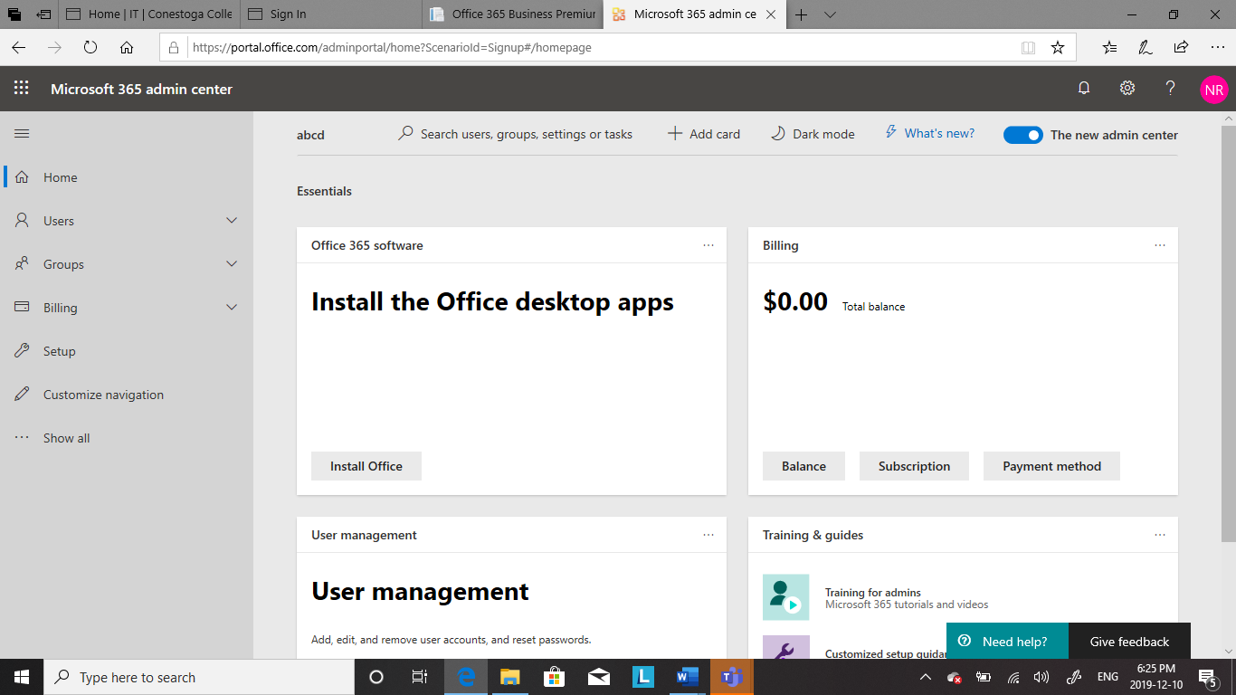

**Figure 1: Microsoft admin center**

* Go to users and click on active users
* Click on add multiple users

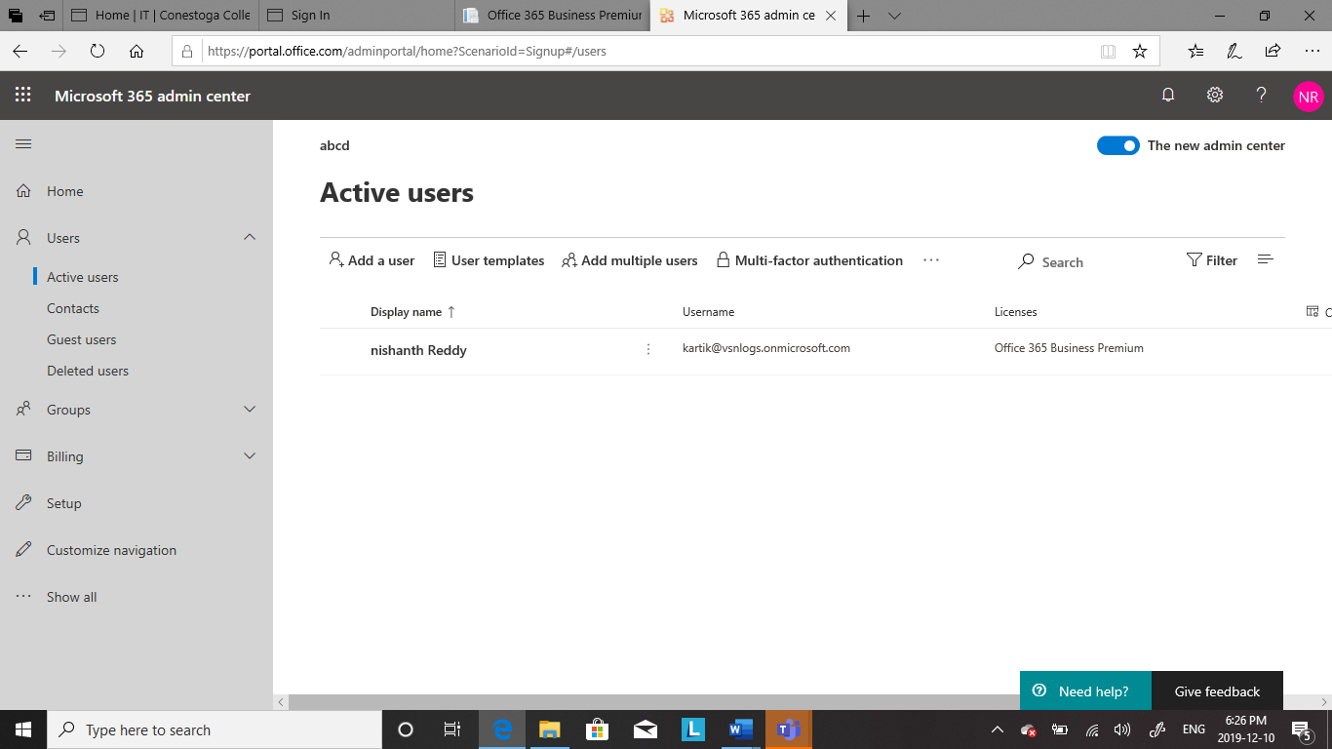

**Figure 2: Active Users**

* On the import multiple users there are two ways available to import multiple users

1. Download a CSV file with headers only
2. Download a CSV file with headers and sample information

* Now click on download a CSV file with headers only

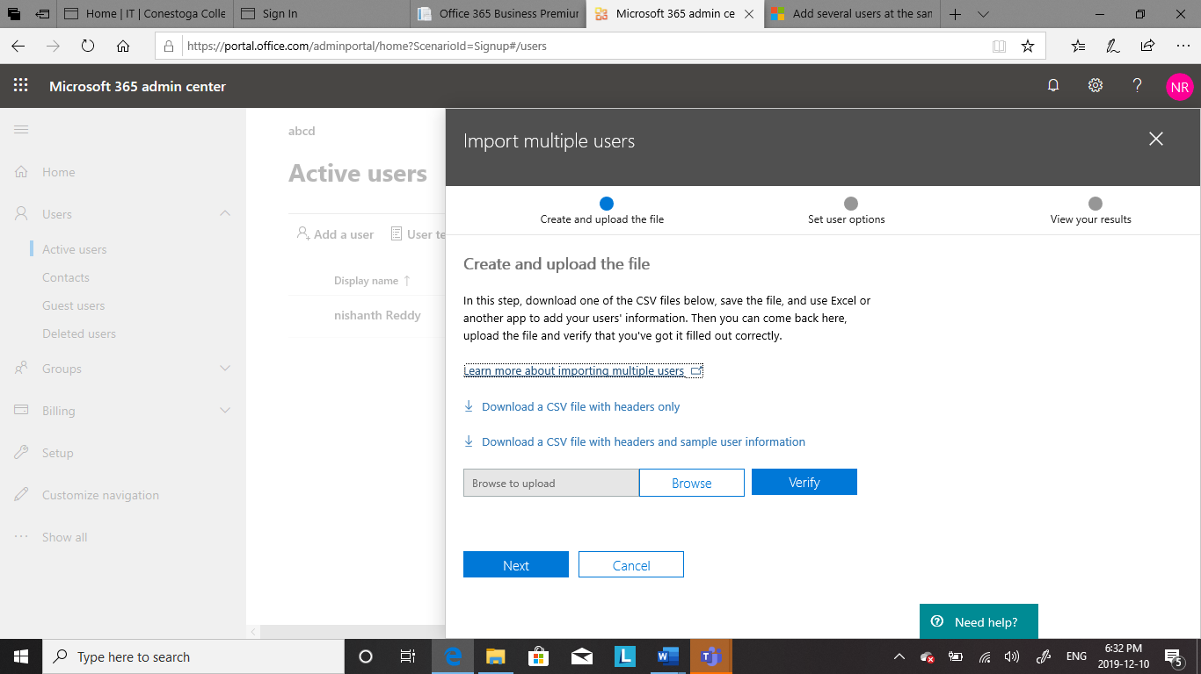

**Figure 3: Create and Upload file**

* Now browse for the saved CSV file and click on verify

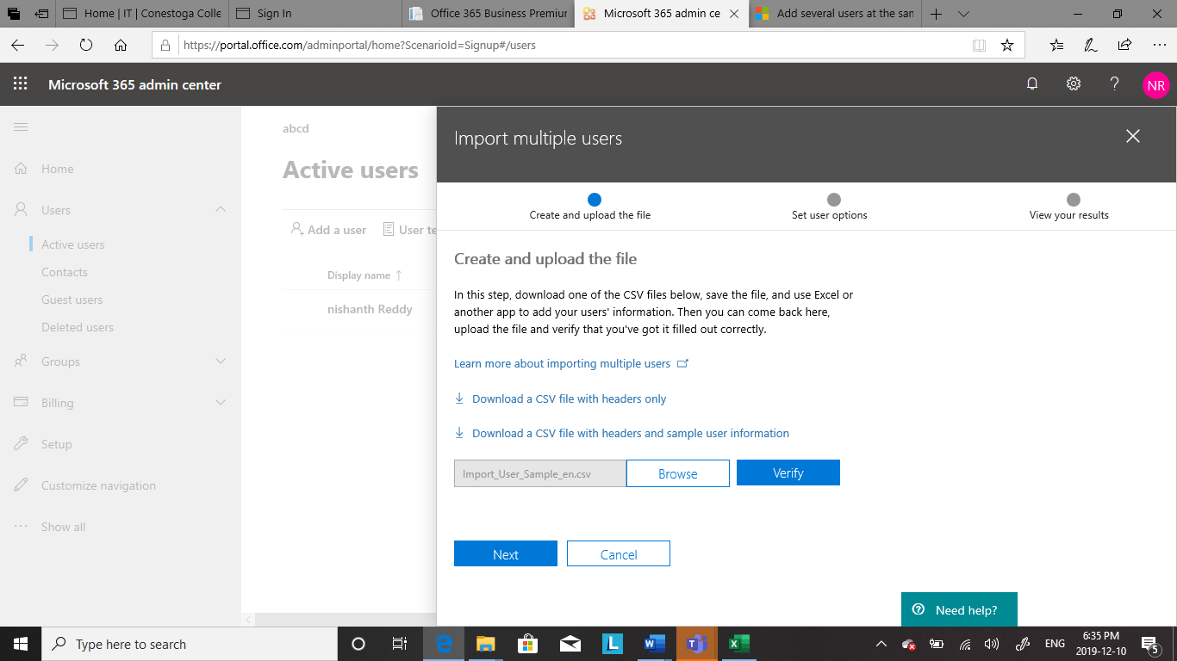

**Figure 4: Browsing the CSV file**

* On the set user Options dialog Box, you can set the sign-in status and choose the product license that will be assigned to all users
* On the view your results dialog box you can choose to send the result to yourself or other users and you can see the number of users created

### **Advantages of CSV Migration:**

* CSV is faster to handle
* CSV is smaller in size
* CSV is easy to generate

### **Disadvantages of CSV Migration:**

* CSV allows to move most basic data only. Complex configurations cannot be imported and exported this way

## **Email Migration:**

### **Migration Steps (PST):**

Step 1: Export Outlook Data File

* Login to Outlook account with username and password
* Select the file tab
* Choose open and export and click on Export/Import

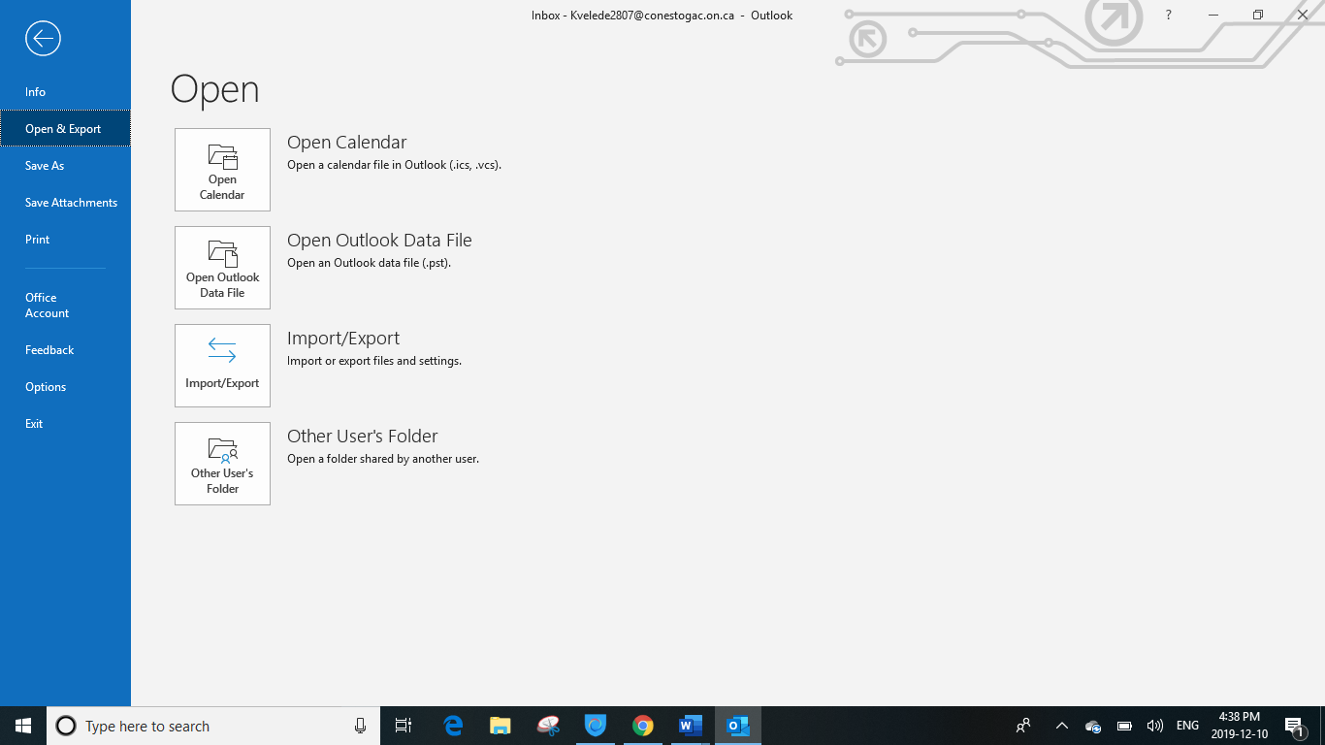

**Figure 1: Choosing Import/Export option**

* Now choose export to a file
* Click on next

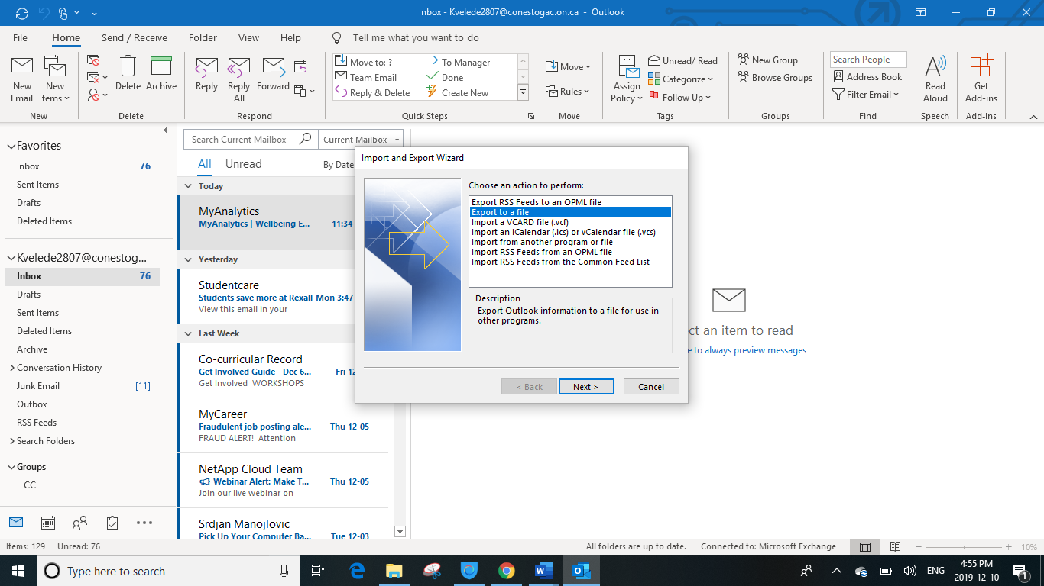

**Figure 2: Import and Export Wizard**

* Now choose Outlook data file(.pst)
* Click on next

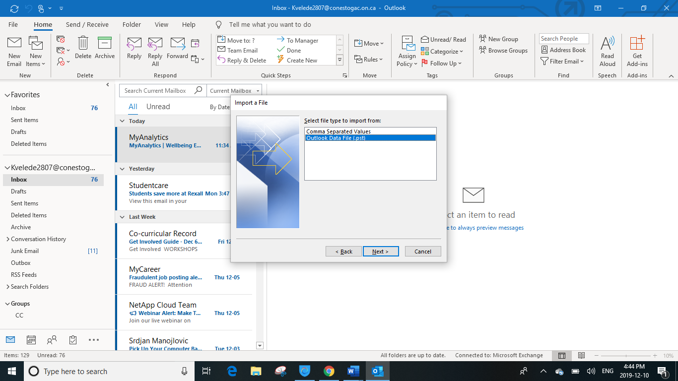

**Figure 3: A place to choose the type of file**

* Now select all the folders what you want to export to a file
* Click on next

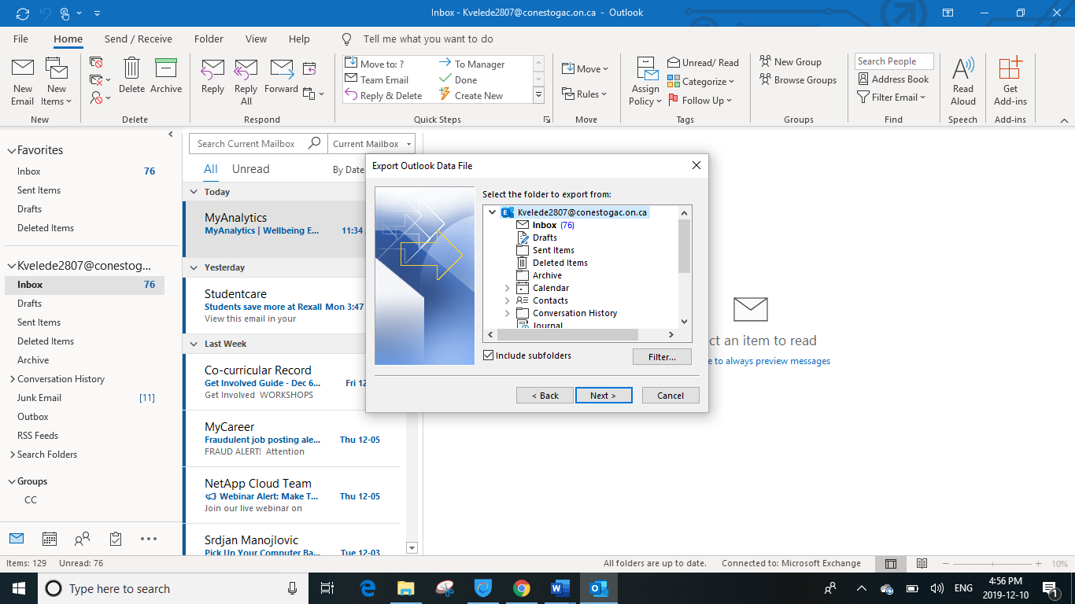

**Figure 4: Export Outlook data file**

* Select Browse, and then select the location where you want the new .pst file to be saved.
* In the File Name box, type the name that you want to use for the new .pst file, and then select OK

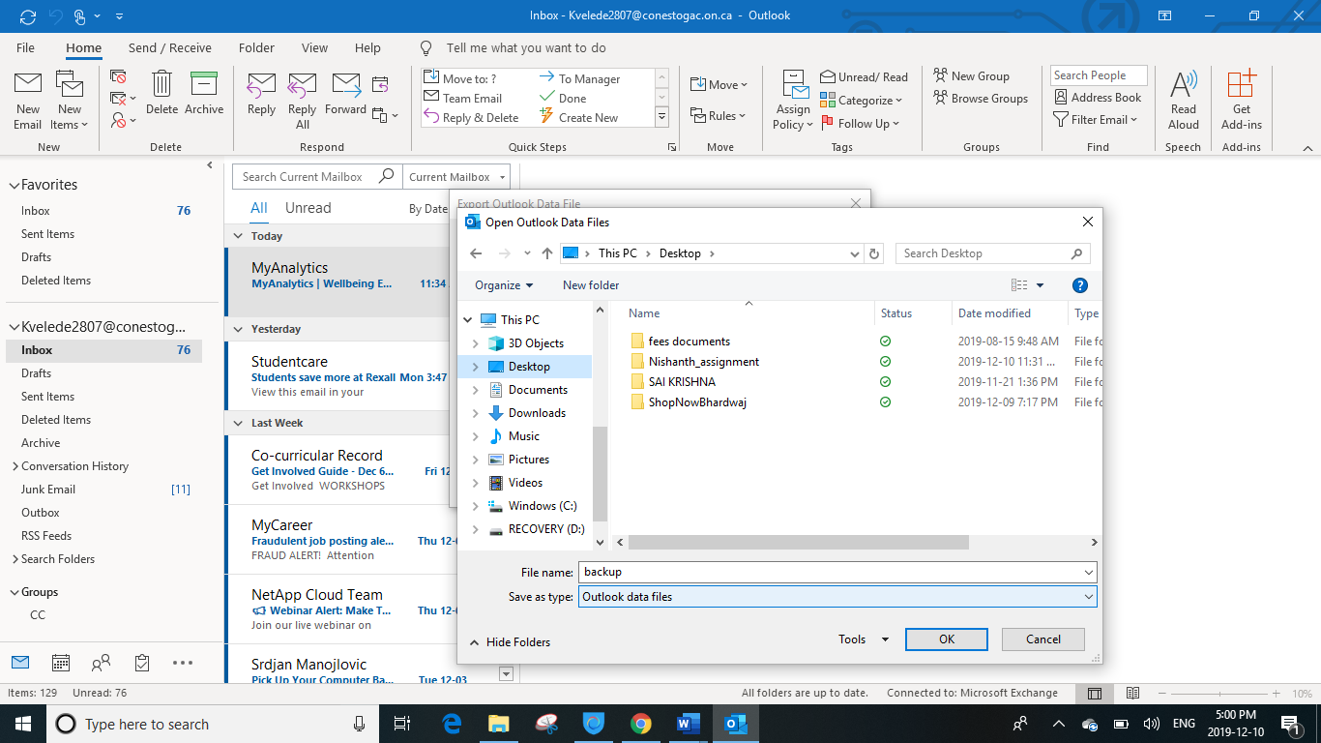

**Figure 5: Choosing the location to save the file and naming it**

* Now select Replace with items exported
* Click on finish

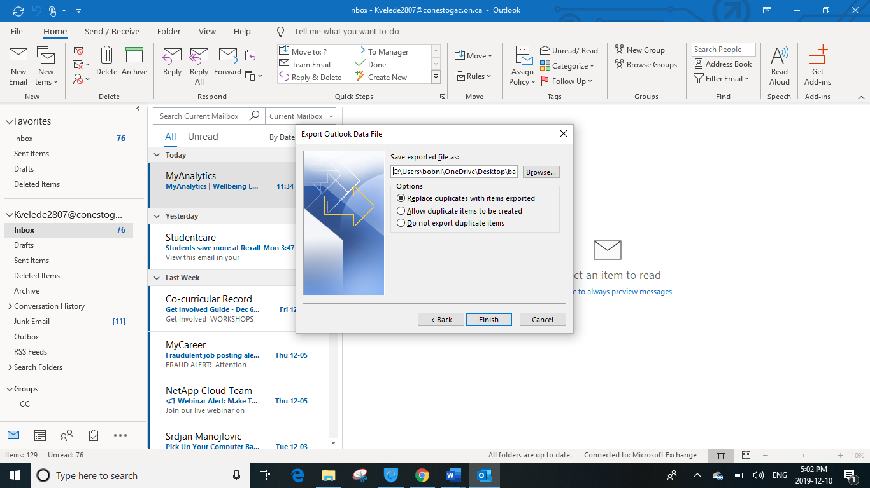

**Figure 6: Export Outlook Data File**

* Now a dialoge box appears asking to create a passord for .pst file in order to protect the file
* Now enter the password you wish to have and verify it
* Click on oK

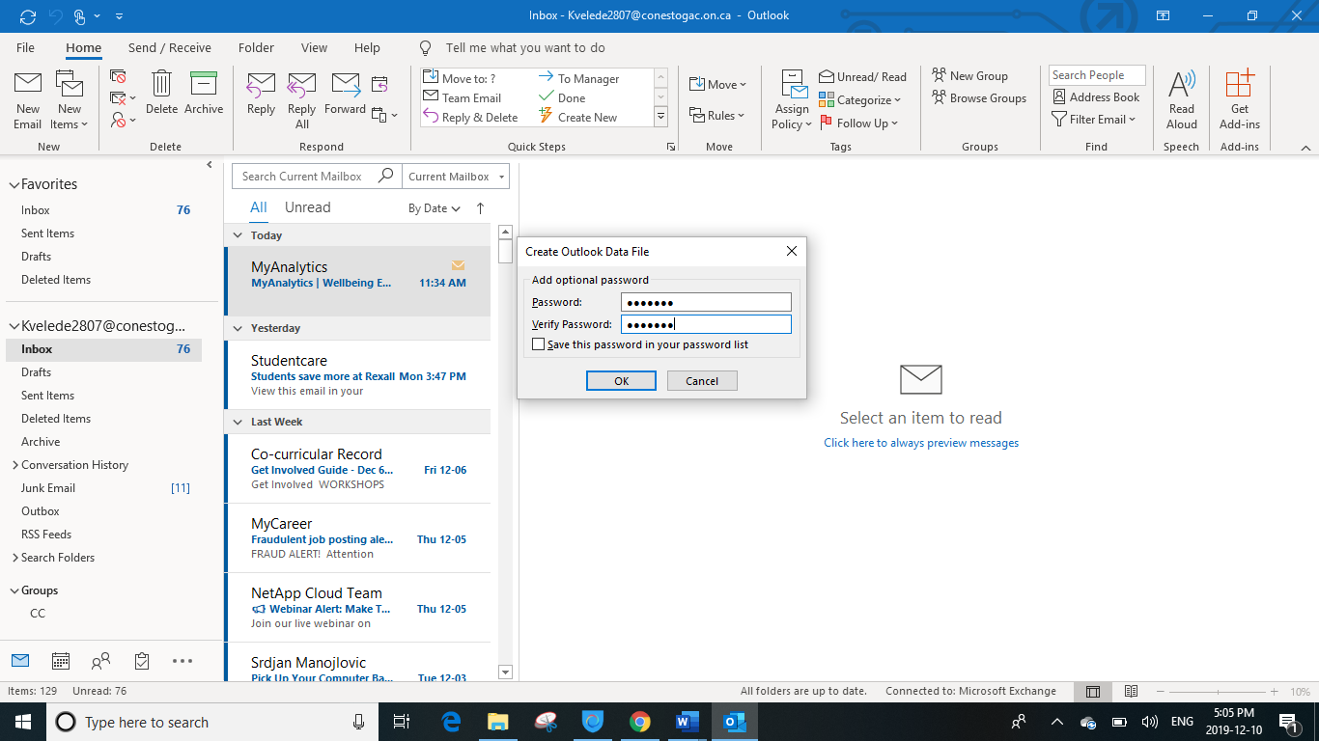

**Figure 7: Add Optional Password**

* Now type the password for backup and click on ok

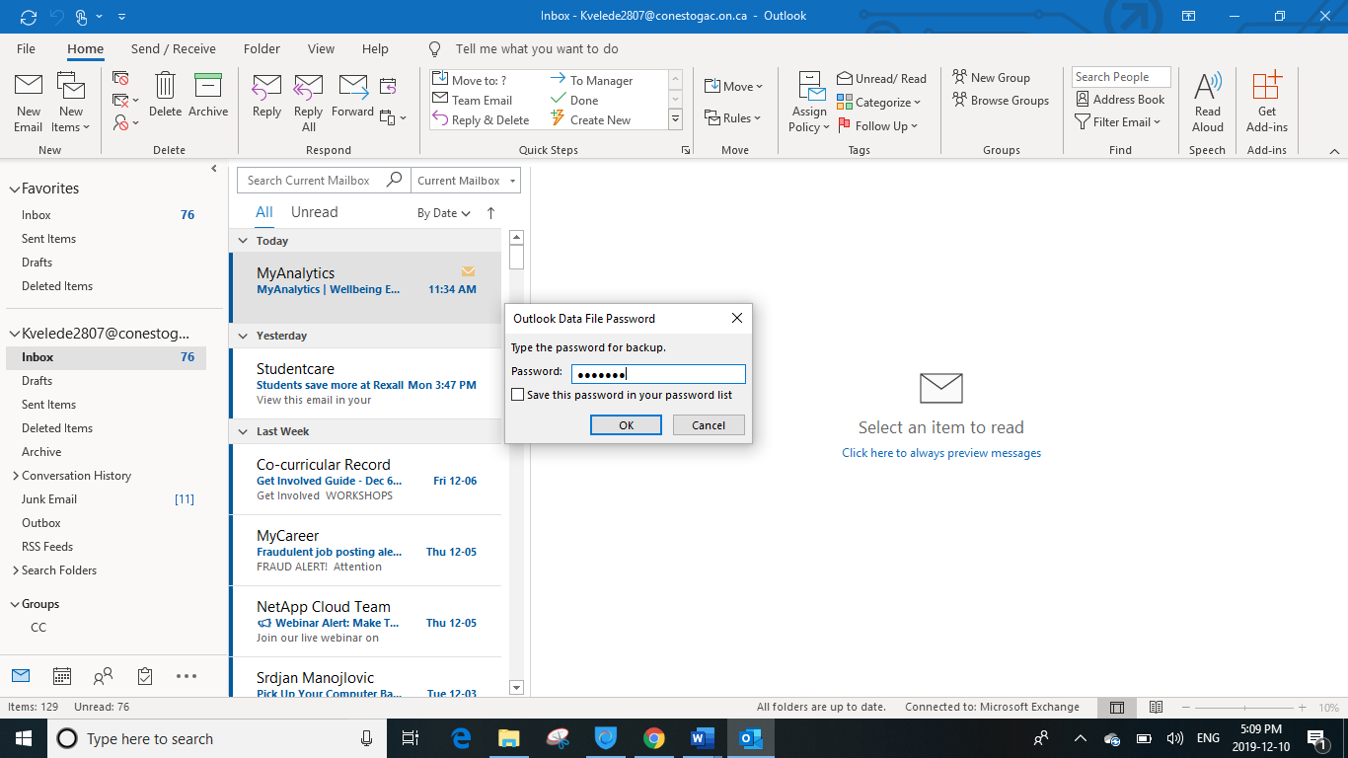

**Figure 8: Backup Password**

Step 2: Import Outlook data file

* Login to Outlook account with username and password
* Select the file tab
* Choose open and export and click on Export/Import



**Figure 9: Choosing Import/Export option**

* Now choose import from another program or file
* Click on next

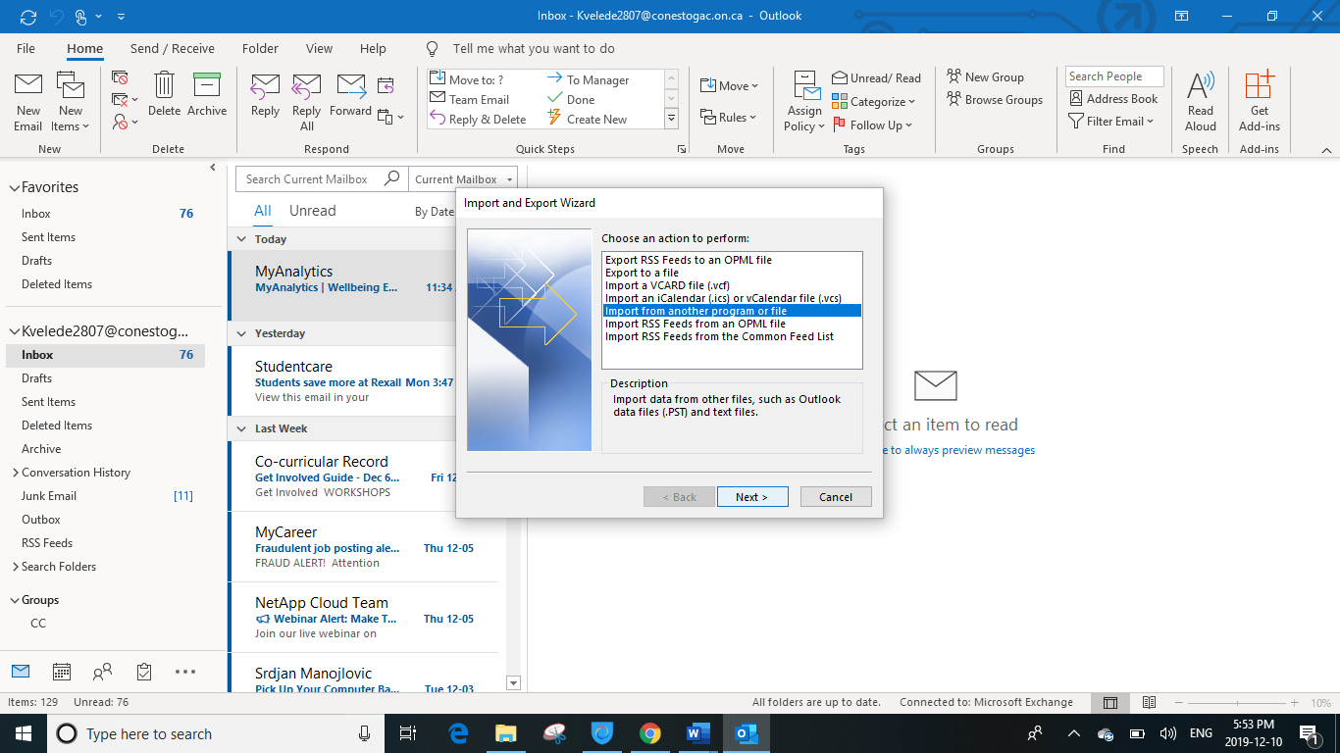

**Figure 10: Import and Export Wizard**

* Now choose Outlook data file(.pst)
* Click on next



**Figure 11: A place to choose the type of file**

* Type the path and the name of the .pst file that you want to import, or select **Browse** to select the file to import.

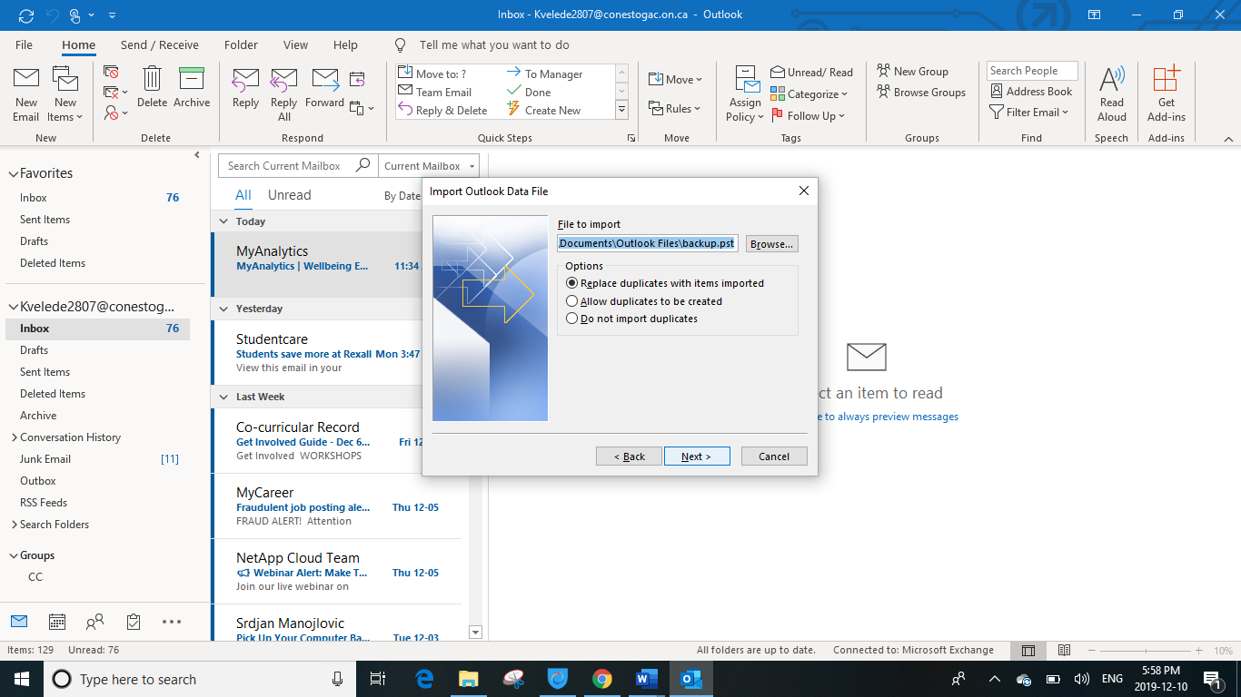

**Figure 12: Selecting the file to be imported**

* Now dialgoue box will appear asking for the password to access the file
* Enter the password and click on OK

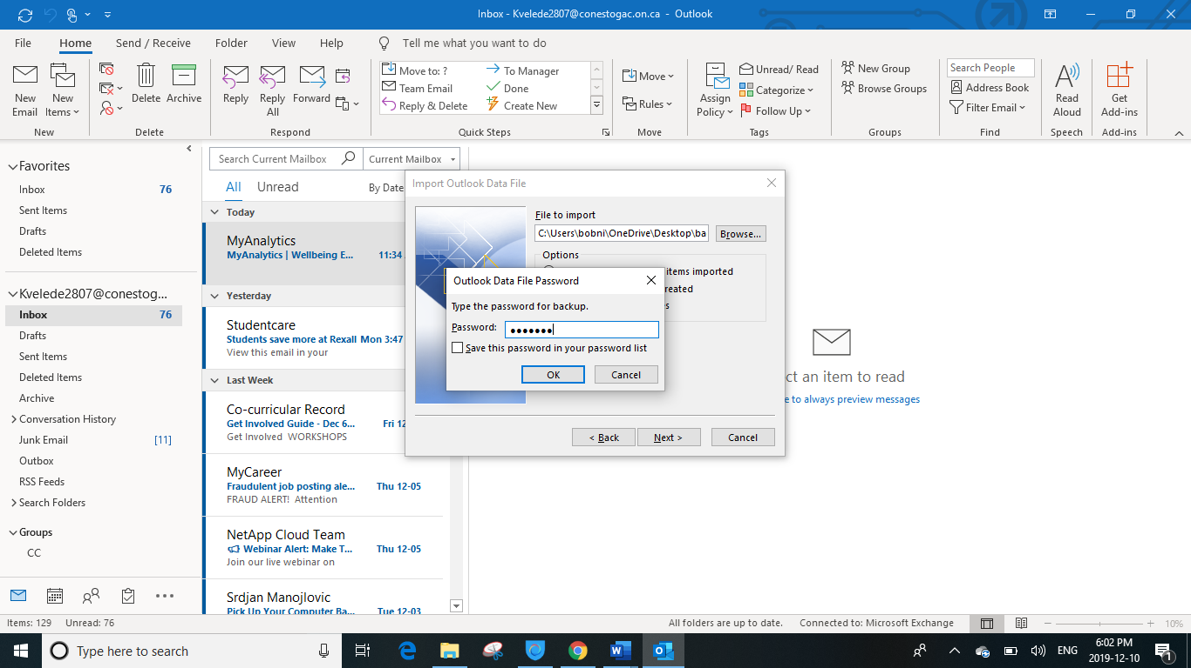

**Figure 13 : Outlook DataFile Password**

* Now select the folder to import the items and click on finish

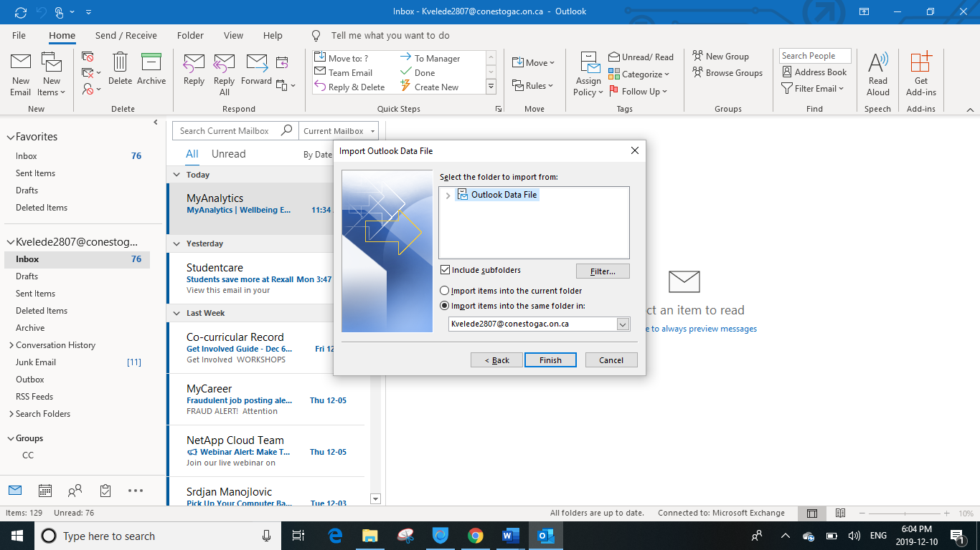

**Figure 14 : Choosing the folder to import the items**

* Now all the items gets imported into the selected folder

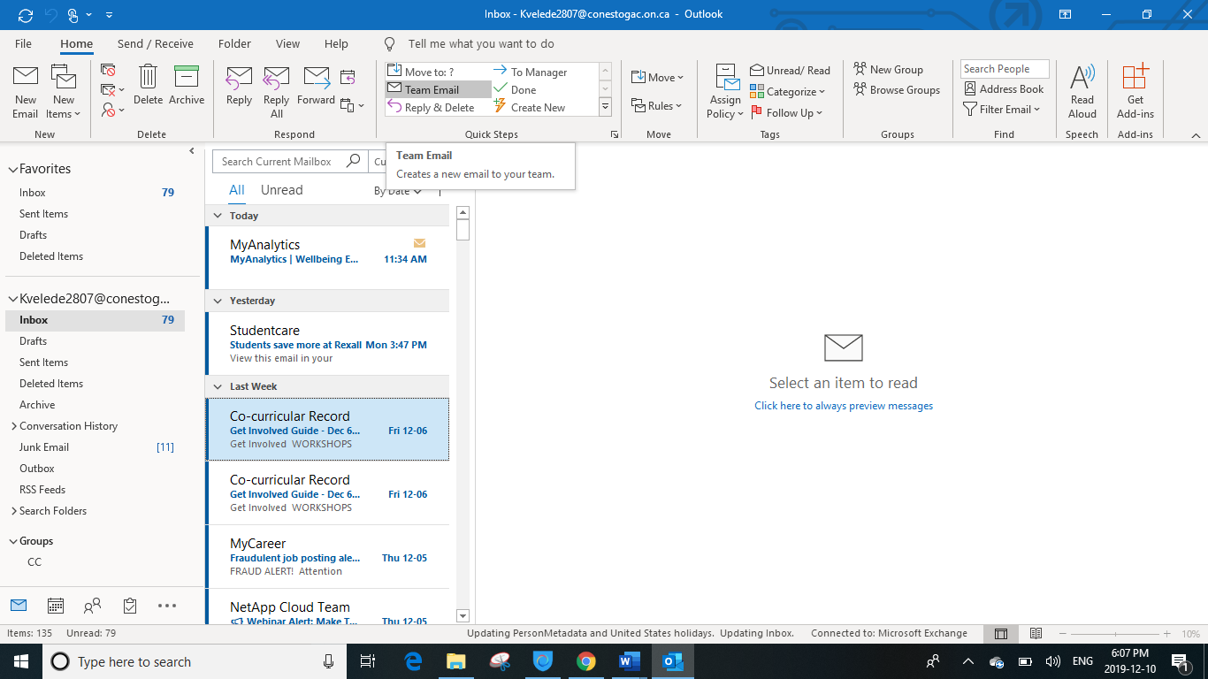

**Figure 15 : An outlook home page after migration**

### **Advantages of PST migration:**

* Users can easily create their own PST files without the assistance of IT
* PST files are stored locally on the user’s computer which allows them offline access to their email data

### **Disadvantages of PST migration:**

* Not centrally managed
* Major security risks
* Legal and compliance obsatcles

## **Data Migration:**

### **SharePoint Migration Tool:**

SharePoint Migration tool is used to migrate small set of files to large scale enterprise to cloud take advantage of the latest collaboration, intelligence, and security solutions with Office 365.

SharePoint Migration tool lets you migrate content to SharePoint Online and OneDrive from the following locations:

* SharePoint Server 2013
* SharePoint Server 2010
* Network and local file shares

### **Advantages of SharePoint Migration Tool:**

* Provides a wizard like interface, allowing you to simplify the transfer of your data from your on-site SharePoint Server database libraries and local share files to SharePoint Online
* Supports the smallest of migrations to large scale migration

### **Disadvantages of SharePoint Migration Tool:**

* NO support for custom metadata mapping
* Not suitable for complex and advanced migration scenarios
* Migration from SharePoint On-premise to another SharePoint On-premise is not supported

# **Gantt Chart**

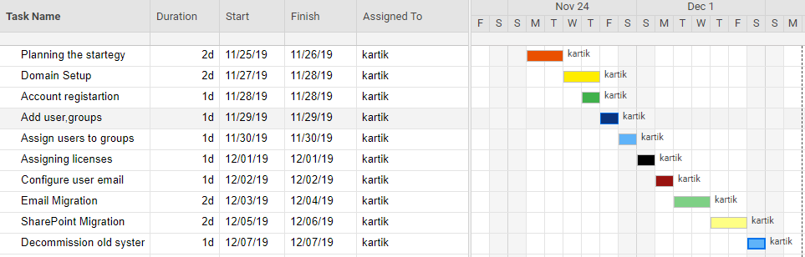

# **References**

Domain setup:

<https://docs.microsoft.com/en-us/office365/admin/setup/add-domain?view=o365-worldwide>

<https://help.one.com/hc/en-us/articles/115005595965-How-do-I-set-up-my-domain-with-Office-365->

Big bang Migration:

<https://datamigrationpro.com/big-bang-data-migration/>

<https://www.cloverdx.com/explore/data-migration>

User Migration:

<https://docs.microsoft.com/en-ca/office365/enterprise/add-several-users-at-the-same-time?redirectSourcePath=%252fen-us%252farticle%252f1f5767ed-e717-4f24-969c-6ea9d412ca88>

SharePoint Migration Tool

<https://docs.microsoft.com/en-us/sharepointmigration/introducing-the-sharepoint-migration-tool>

<https://sharepoint.stackexchange.com/questions/232142/the-microsoft-sharepoint-migration-tool>